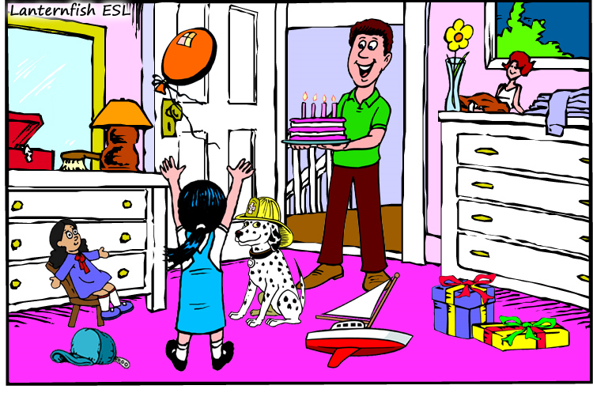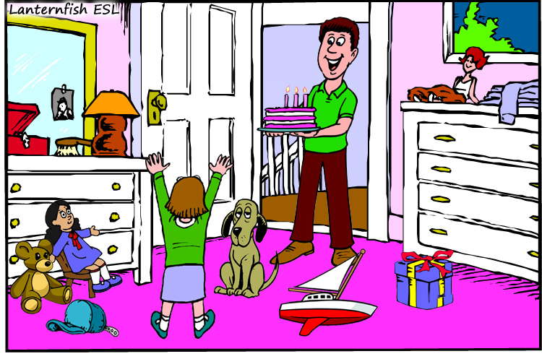
Picture A Picture B
Look at the two pictures of the room. Circle as many differences as you can and then write the differences below.
(1) | e.g. In picture A, the dog is wearing a hat.
 | In picture B, the dog is not wearing a hat.
(2)
(3)
(4)
(5)

